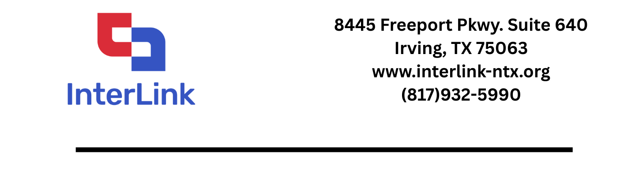
InterLink is the Regional Convener for the Greater Dallas Workforce Development Area. The purpose is to convene secondary, post-secondary, industry, and workforce to develop relevant career pathways to benefit workforce development in the region and specifically to benefit the students with partnerships that provide dual credit, work-based learning, and industry credentials with value in the labor market.
Greater Dallas includes 14 Dallas County school districts, Dallas College and other Dallas County colleges and universities, Region 10 Education Service Center, Workforce Solutions Greater Dallas, and Dallas Regional Chamber of Commerce.
Below are the 7 components of high-quality pathways that are woven throughout the Texas Regional Pathways Network. These components provide for quality Career and Technical Education programs.
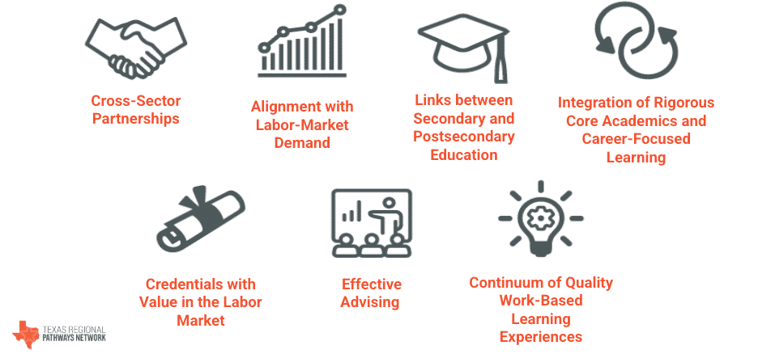
Following is a link and address to the website that provides in-depth information for the Texas Regional Pathways Network.
Texas Regional Pathways Network (www.txpathways.org)

